TallyConnect – Visual Comparison References
Flutter APK vs Approved Prototype
Use this document as a visual reference during the Flutter audit. Main.dc.html remains the primary source of truth. The screenshots are provided to identify visual/layout differences, especially card dimensions, spacing and alignment.

1. Current Flutter APK Screenshots
Flutter APK – Home / Dashboard
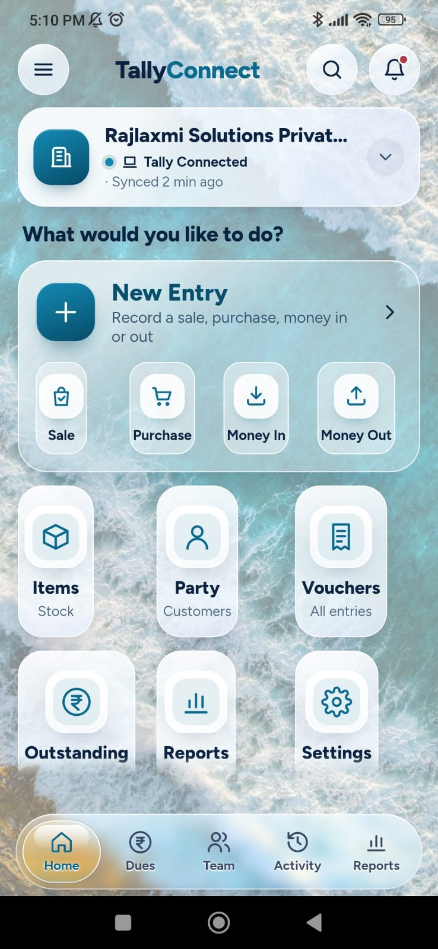

Flutter APK – Home / Money Summary
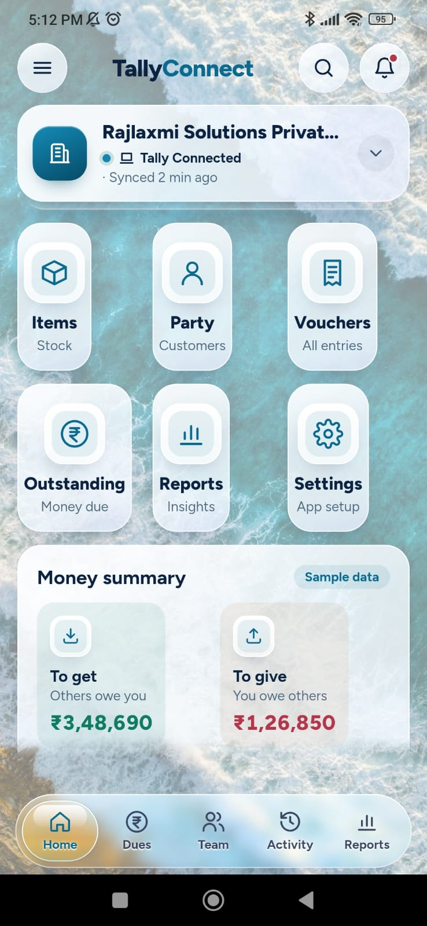

Flutter APK – Home / Scrolled Money Summary
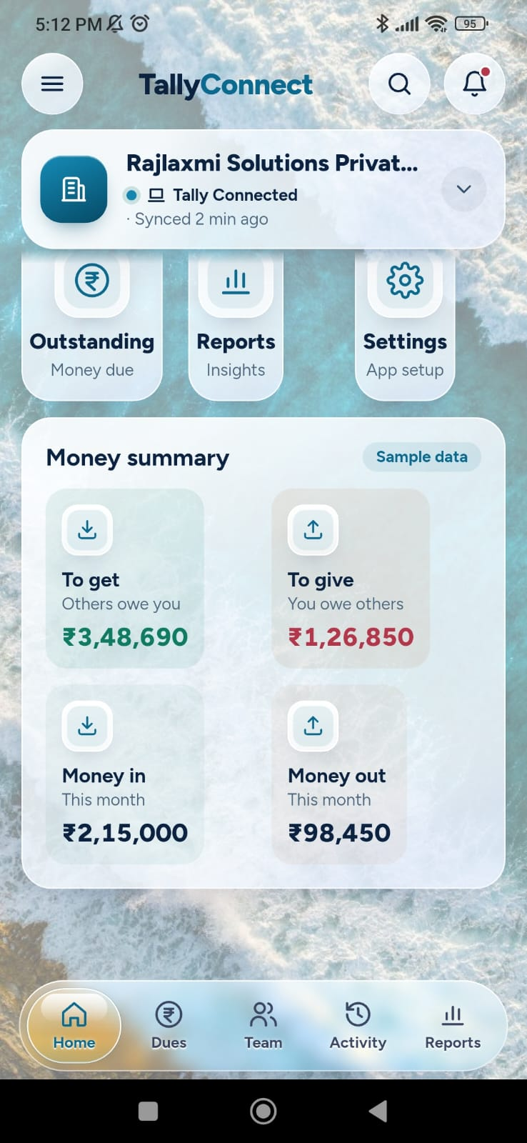

Flutter APK – New Sale / Payment
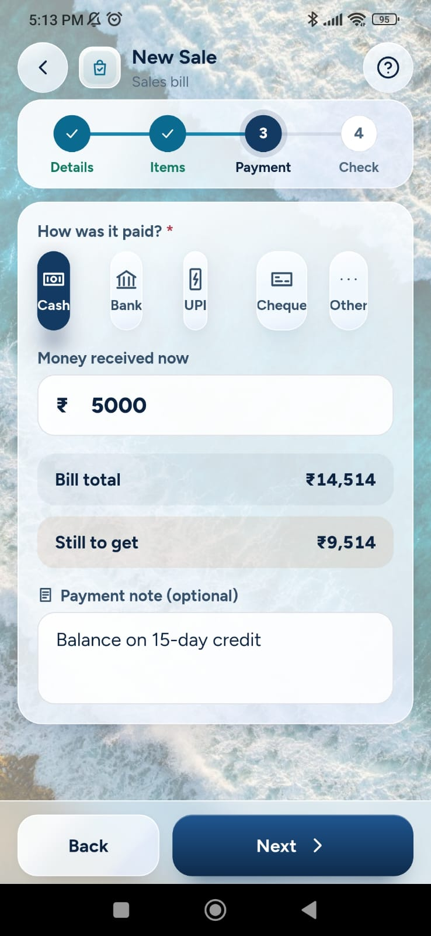

2. Approved Prototype Screenshots
Approved Prototype – Home / Dashboard
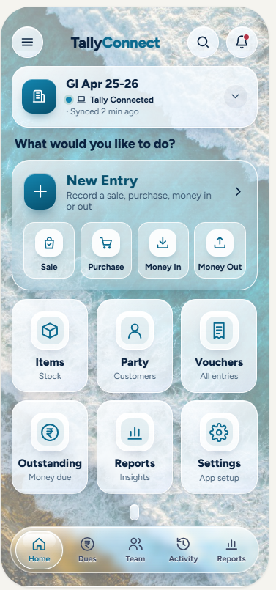

Approved Prototype – Home / Money Summary
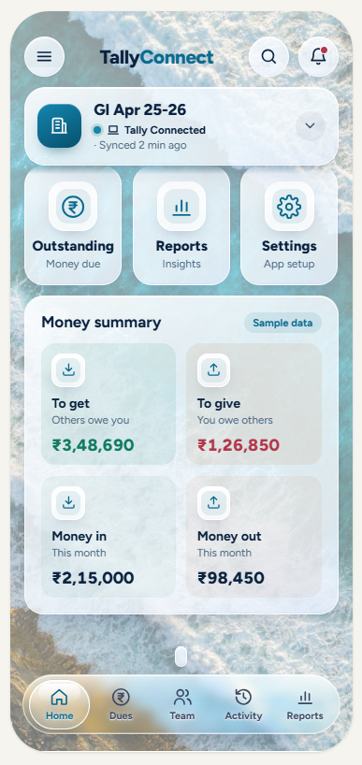

Approved Prototype – Reports
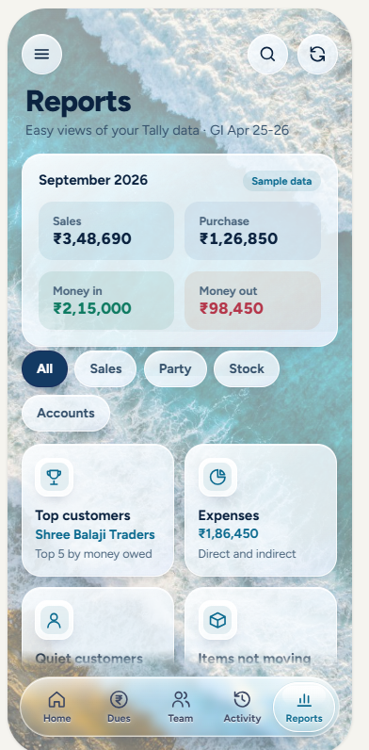

Approved Prototype – Report Detail
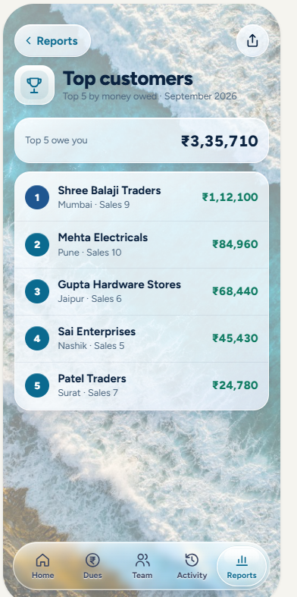

Instructions for Claude Code
- Compare the Flutter screenshots against the corresponding prototype screenshots.
- Audit card width, height, margins, padding, gaps, row/column alignment, typography and positioning.
- Do not redesign the approved UI. Fix only mismatches and preserve existing functionality.
- Main.dc.html remains the source of truth for existing prototype behavior and design.
- The Share/PDF/Download and Report Chart requirements are new additions and should be implemented without disturbing the existing design.
- Do not begin coding during the audit phase; first produce the complete fix plan.

